Infra-red receiver and Raspberry Pi
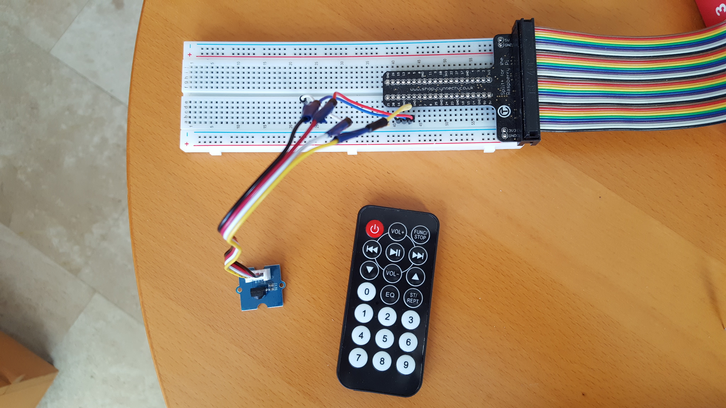

Background
Given that I had ordered a package with all kinds of sensors about 2 years ago, I have done a number of projects using that material. I am focused on “where hardware meets software”. This time I wanted to better understand Infra-Red communication. There is a lot of good documentation available (mostly for Arduino), but wanted to make a receiver working on a Raspberry Pi. It turned out a bigger challenge than expected.

The Infra-red protocol (IRP) notation is a challenge by itself. I had to restart 3 times to read a document from JP1 remotes about this topic. That document only describes how to read the notation. It is very detailed described but it is complex to understand. However once I got through that, it is insane to see how many protocols and variations there are.

One should ask “WHY DID THEY MAKE THIS SO DIFFICULT ?¨ Different protocols for something that does exactly the same. The “wheel” of infra-red remotes control has been re-invented hundreds of times and that still happens. Not only the protocol is different, but different remotes (using the same protocol) transmit different values (OBC) for a same key pressed. Actually crazy.

Not only was the understanding of the protocol a challenge, it turned out that the 1838T IR-receiver that was part of the sensor kit, was apparently not able to handle some of the signals. I have written a chapter about that discovery and an in-depth explanation why that did not work.

In the end I have implemented only a handful of the most common remote protocols ( Philips RC5 & RC6, NEC and Sony). As I also have a Daikin air purifier with a remote I have that implemented as well.

Paul van Haastrecht ( paulvha@hotmail.com)
May 2017

Table of Contents
Background 1
Hardware 2
Software 3
High level description of program flow 3
Reading signal 3
Decoding 4
Installing the software 4
1838T and Philips RC6 5
TSO2838 and the RC-6 protocol 9
Literature 10

Hardware

The hardware setup is not difficult. It actually, it is 3 wires.

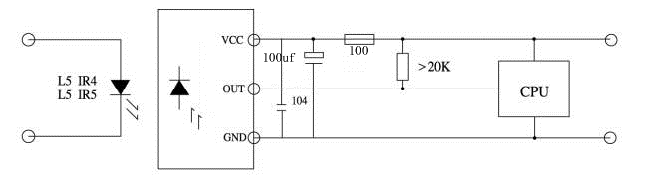
Source: data sheet 1838T

As I wanted to be able to remove the power, I used GPIO 12 to switch the power on/off. According to the data sheet the sensor only takes 0.8mA. You need to have a pull-up resistor of 27K, as the 1838T leave the line floating, when now IR-signal is received. It also needed the 100 ohm / 100uF capacitor. At first I did not have that and the 1838T worked in stable.

As described in the chapter “1838T and Philips RC6”, given the Manchester time coding applied by Philips, the timing was even more critical. The 1838T just could not cope with it, although specs say it can. Maybe it is specific to my IR-receiver, maybe it is generic, but I had it replaced with TSOP3828 from Vishay. I have documented the results of that in “TSO3828 and the RC6 protocol” Chapter.

The TSO2838 is implemented on a Grove board ( 101020016) which I have connected directly to the Raspberry Pi. The schema is below.
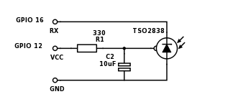

Software

As with many projects I make use of the great BMC2835-Library. This allows to be working directly on I/O of the Raspberry PI hardware (BCM2835/BCM2837), instead of working through the kernel drivers. It is fast and brings the flexibility & insight that I am looking for.

The program is written in C and the following modules make it to one executable:

receiver.c main program
receiver.h header file program variables.
decode.h header file with decoding information
mrec.sh compiler instruction

High level description of program flow
From main(), read_signal() is called. This will loop until it times-out (read_time_out) or reaches the maximum samples (MAX_COUNT) to detect the signal going low and high. The time at which that happens is stored in micro-seconds in the “rec_signal” structure. It will return the number of samples taken.

From main(), decode_data() is called where it tries to detect the decoding protocol based on the starting flash/low/mark signal. Each of the defined protocols has it’s own length. If detected it will call decode_data_xxx(), where xxx is the name of the protocol.

Each of the decode_data_xxx() will apply different decoding logic, but the structure is nearly the same. It will loop through the samples, detect the starting point, detect whether the current bit is to be set as ‘1’ or ‘0’, detect whether a single byte has been done and store that in rec_bytes.buf, updating the count of bytes in rec_bytes_cnt. It will detect whether all the bytes have been done and return a ‘0’, to indicate it was successful. If there is a protocol error during the decoding, it will return a ‘-1’.

From main() it will call display_data() if a ‘0’ was returned. Display_data() for Philips and Sony it will try to detect the kind of device that is being controlled and will try find a match for each device and command byte and display the key that was pressed. The information that is in decode.h is used for that, which is by far not complete but handled the 5 remotes that I have tested well

Reading signal
It is a know issue that the IR-receiver will get false reading, based on the surrounding / light conditions. (see the datasheets) Over the many years new levels for Automated Gain Control (AGC) had been developed (up to level 4) to reduce the wrong readings. However especially with the 1838T and to a lesser extend with the TSOP2838 (AGC-2), I still got short spikes. In order to reduce the false readings, spikes shorter than neglect_pulse (100us by default), will be skipped and not stored. The 1838T & TSO2838 has a minimum valid burst time of 280us, hence I decided that 100us is save enough boundary.

If requested a pulse will be generated on GPIO 8 . This can be used to track with an oscilloscope the reaction time of the Raspberry Pi.

Decoding

Unlike with Arduino, where the decoding of ‘0’ and ‘1’ is done at the time of reading the signal based on exact sampling of the input signal, the decoding in this program is based on logic. The stored time for start and stop are interpreted with higher margin : Assume a pulse is to be 440us and thus double pulse is 880us, the logic will check for below 500us and above 800us.

This has NOT been done because the Raspberry Pi/Linux is not a real-time system. Using the test pulse during read_signal(), clearly showed that there was not an issue. However it brought other advantages:

- Although protocols define an exact amount of time for each pulse, the 5 remotes that I have used for testing all had a margin of error and did not produce twice the exact same timing. This program is far less sensitive to timing errors and able to cope with a large degree of variations.

- It is easier to add a protocol, as you do not need to know at the time of reading the signal, what protocol the remote is using. That makes it easier to add different / more protocols and let the program detect and decode this afterwards.

- Many remotes can handle multiple devices (DVD, TV, Tunes etc.) In many situations those devices have a different protocol. That is now automatically detected.

Installing the software
Make your self superuser : sudo bash
BCM2835 library
Install latest from BCM2835 from : http://www.airspayce.com/mikem/bcm2835/
- cd /home/pi
- wget http://www.airspayce.com/mikem/bcm2835/bcm2835-1.50.tar.gz
- tar -zxf bcm2835-1.50.tar.gz // 1.50 was version number at the time of writing
- cd bcm2835-1.50
- ./configure
- sudo make check
- sudo make install

Install the receiver utility
- cd /home/pi
- tar -xzvf ir-receiver.1.tar.gz
- cd irr
- ./mrec.sh

The program has the following command line options :
-n, Neglect pulse shorter than X us. (default: 100 us)
-t, Set time-out seconds during reading signal. (default: 3 seconds)
-d, Enable debug messages.
-T, Enable test pulse on GPIO 8.
-h Show this help text.

1838T and Philips RC6

The RC6 protocol from Philips was causing major issue with the 1838T. Sometimes it works, sometimes it does not.

According to the specification the 1838T, needs a flash of at minimum 280us before generating a low output signal and at least 300us gap in between flashes.

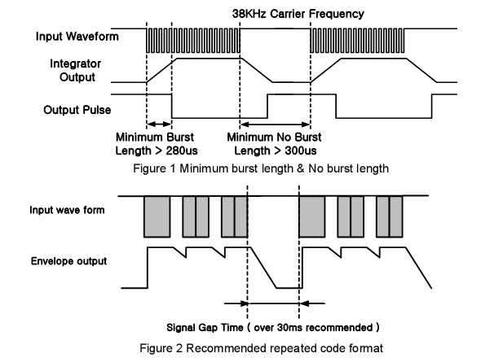
RC-6 is using the Manchester decoding, which means that within a slot time of 880us:
If the first half is a flash, followed by a gap, this represents a ‘1’,
when starting with a gap, followed by a flash, this represents a ‘0’

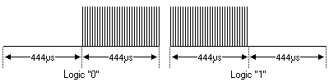

RC5 also uses Manchester time coding, but the time is 880us and the ‘1’ and ‘0’ is exactly the opposite of RC6, as well as the toggle bit being on a different place.
Time for real test…

In yellow the signal as transmitted by a Philips remote (RC-5340), the red signal as it comes from the 1838T output. You clearly see the leader signal: ~2.7ms flash + 440us gap. That is weird already at the gap should be 2 x 440 = 880us. The 1838T seems to follow the remote signal, but if you look later to the signal (8th flash after leader signal), you’ll see that the flash is NOT detected by the 1838T. Later that happens again. This could be reproduced most of the time.

Taking a closer look at the timing of the 1838T. Between the start of a flash(yellow) and the output signal (red) of the 1838T going low is about 180us, between the start of a gap (flash is stops) and the signal going high is about 400 us.

The next picture is zoomed in on that point . The time scale is 100us and from start of the flash to the 1838T signal going low is 180us, when the flash stops to the output signal going high 440us. The yellow signal is of course a sinus wave at ~36khz.(28us)

With the RC-x signal, we now have a problem. A gap after a flash apparently needs ~440us in order to be detected. If the next flash happens before that time, we are out of luck. Maybe it was my 1838T, but it was missing to detect the next flash as can be seen when zooming in on the missed detection.

The 180us needed to respond to a flash can be seen above as the difference of the start of the first flash (yellow) and the output of the 1838T going low (red). After a gap of ~440us the next flash happens, but is missed by the 1838T.
That said….sometimes I was very lucky and it worked

However most of the time it did not detect as we are working on the boundary/limits of the 1838T, although the specification states that 300us should be enough, but it was NOT…

Next to this issue I got many random spikes of 80us – 250us. It is known that outside light can have a big impact and that should be corrected with the automated gain control (agc), but it was not happening enough. In the code you will still find a way to remove spikes shorter than 100us and command line options that change that number

What to do NOW ???? well… I ordered a Grove IR-receiver (101020016) with TSO2838 from Vishay, which according to specification can work with the RC-6 protocol.

TSO2838 and the RC-6 protocol

The TSO2838 specification needs a minimum burst/flash length of 10/f0 and gap of min 10/fo and max 70/f0, unless the burst/flash signal was more than 70/f0, in that case the gap needs to be 4 x burst/flash length.

With 36khz for RC-6, that means 10 x 28us = 280us is the minimum burst/flash length and minimum 280us gap length. The RC-6 protocol has 440us pulses/gap so we should be good.

Below you the RC-6 signal from the remote RC-5340 (in yellow) and the detected output from the TSO2838 (in red). The good news is that all bursts are detected. Also good to see the leader-signal is what to be expected: burst of 2.7ms + a gap of 880us (as expected).

Let’s zoom in on the reaction time :

yellow: remote control signal
red : detected signal

TSO2838 takes about 200us to detect either a flash (red signal going low) and a gap (red signal going high), of about 8 cycles

As that is the SAME time, the detected output time is nearly the same as the transmitted time, only with a delay of 200us.

Now our trouble is over.

As with the RC-6 protocol the first bit is a 1: flash 440us of followed by a gap of 440us. As this remote is for Philips consumer electronics, the 3 modes bits that follow are ‘0’. Thus first ‘0’ is a gap of 440us (making the total for the second gap of 880us) and a flash of 440us, the second.

Literature

Infra-Red Notation
http://www.hifi-remote.com/wiki/index.php?title=IRP_Notation

1838T datasheet
http://projectpoint.in/datasheets/pdf/1838T.pdf

TSO2838 datasheet
http://www.alldatasheet.com/datasheet-pdf/pdf/26641/VISHAY/TSOP2838.html

Many places on Internet (searched with Google)
eas example
https://en.wikipedia.org/wiki/RC-5
http://www.sbprojects.com/knowledge/ir/rc6.php
http://www.sbprojects.com/knowledge/ir/sirc.php

